
ELIM SOCIETY FOR SENIORS CARE
IN SOUTHERN ALBERTA
2025 | Annual Report

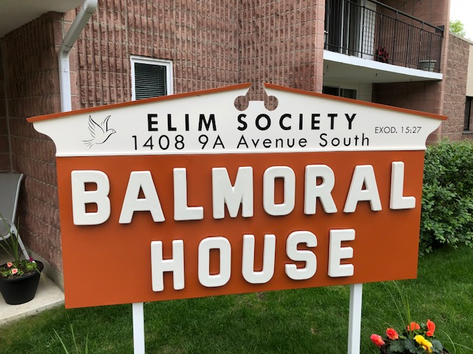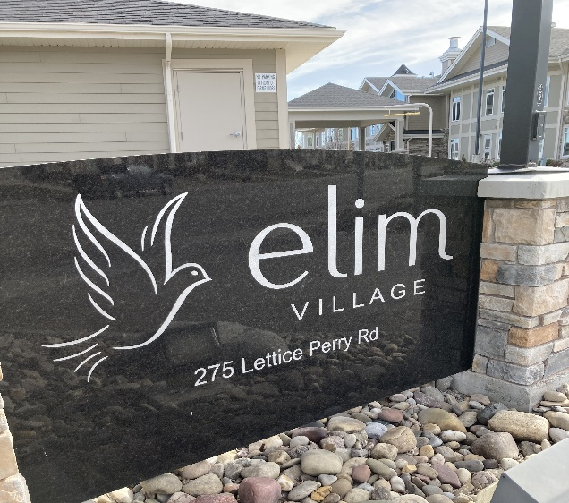

275 Lettice Perry Road North, Lethbridge, AB T1H 7E7
Phone: 403-942-2672
www.elimlethbridge.ca
PRESIDENT’S REPORT AGM 2025-26
“Do not be anxious about anything, but in everything, by prayer and petition, with thanksgiving, present your requests to God. And the peace of God, which transcends all understanding, shall keep your hearts and your minds in Christ Jesus.
Even while Paul was a prisoner in Rome, he was able to write a letter to the Philippians that overflows with joy and encouragement. When the Lord is near to us, we can lay aside all worries! Paul’s instruction addresses the universal problem of anxiety by offering a specific, practical remedy: prayer with thanksgiving. He does not minimize the reality of difficulties but redirects the believer’s response from worry to worship. How much that reflects the condition of our times as well! There are many reasons for anxiety and worry in this world, but what a blessing that we can bring all our troubles to the Lord in prayer, and count His blessings!
We are pleased to report that we have experienced another year of blessings at Elim Village and Balmoral House and we are thankful to the Lord for His goodness and care. May these blessings encourage us to be united in glorifying Him and loving each other, as Christ has loved us. 1 Peter 3: 8-9, states, “Finally, all of you, be like-minded, be sympathetic, love one another, be compassionate and humble. Do not repay evil with evil or insult with insult. On the contrary, repay evil with blessing, because to this you were called so that you may inherit a blessing.” As the Board and its committee members faced questions and challenges throughout the year, we were able to lay these before the Lord in prayer and may say that God has guided our decision making and provided the resources we needed. We are very thankful for His rich blessings to us!
All suites at Elim Village and Balmoral House are currently filled and we have a waiting list at both locations. This has been a real blessing to all of us as we work to continue to have balanced budgets. Nevertheless, we are all aware that the cost of living continues to rise and food costs especially are rising steeply. This has meant that rental rates have had to increase.
The Finance Committee is thankful to report that our mortgage has been renewed. The loan for 5.4 million has been amortized over 25 years on a 5-year term at 5.44% at the Christian Credit Union (CCU). The Evergreen Loan of $500,000 which we received will be at prime +2% bringing that to 6.95% at present. The CCU recommends that we buy out the existing life lease and discourage endorsing any new life leases for they are a losing proposition. CCU also recommends not taking on any new promissory notes although we have the option to renew or pay out existing promissory on maturity or by request. Any capital expenses over $10,000 need to be approved by the CCU, meaning that is the ceiling amount, where we can only spend up to that amount, pay down some, and purchase up to that amount again. We are also considering the building of a capital reserve fund to cover repair and maintenance costs that are inevitable as buildings age. An appraisal was done for Elim Village in order to renew our mortgage. We note that the City’s appraisal is 2.0 M higher than the mortgage appraisal we received of $10,500,000. We have asked the City of Lethbridge to review their assessment in light of the new appraisal, and to request a lowering of the property tax bill assigned to us.
With the increased funds received from the tenants at Elim of $100/month each year for food services, the budget will be brought in line. With the new loan secured it has reduced our monthly payments to nearly half of what we were paying.
Most residents received a rent increase on March 1. Those who didn’t will receive a 90-day notice before their rent increase is implemented. Going forward that same date will become their yearly anniversary date for rent increases. New residents will receive a rent increase on their anniversary date of moving in. The Finance Committee will do a rent review each year by July 31. Starting May 1 a $100 increase per person will be added to reflect increased food costs. There will be an annual calculation of food costs in March/April each year and this will be reflected in rental contracts effective for all units on June 1 of each year. Going forward, updated rental contracts at Elim will include itemized fees for: monthly accommodation rates, other(food) and other (garage, where applicable). The garage fees will also be reviewed annually in June.
A review of the rent at Balmoral House showed a difference in rent per sq. ft. for each individual suite, ranging from $1.33 to $1.93. An increase of rent is proposed this year of 0% to 2 ½ to 7 ½ % depending on the rent currently paid, and to be reviewed in subsequent years, so as to equalize the rent per sq. ft. in the coming years.
Many commented on the positive experience of the Elim fund-raiser dinner held at the Italian Canadian Club on October 24, 2025, and the great food that was served. We had 96 people in attendance, and donations raised $35,830.00 which was designated for a replacement A/C compressor located on the east side of the building and security cameras at Elim Village. Some capital requests in the coming year for Balmoral House are: Wi-Fi (for office, common room) and cameras, for internal and external surveillance and an upgrade in common air supply. There was an attempted break in at the south door of the games room at Balmoral House. Possible installation of a camera or motion light may be forthcoming. The possibility of a donation of a full-sized pool table for Balmoral House will be investigated. Capital requests for Elim Village include the following: paint hallways and grand-room, varnish entryway staircase, guest room air conditioner, gravel for landscape beds and internal and external surveillance cameras.
The Board modified the wording in the Elim Village Resident Policies and Procedures manual (Dining Room Guests RES 09, procedure 5 December 2015) to read: Residents will receive a credit of $70 for each full week they are away, which they can apply to guest meals or in the event it is not used, build credit over their time of residency and will be paid by cheque when leaving Elim Village. Shorter absences will not qualify for credit. (November 27, 2025). Values to be reviewed yearly.
The Board reworded the Staff Policy 2025, 06 Performance Reviews for Administrator to read: The Elim Administrator’s performance review will be carried out in February, and will include, an opportunity for the Administrator to provide a self-evaluation as well as a written evaluation by a meeting with two members of the Board. The reports will then be reviewed at the next Board meeting.
Regarding the policy for prevention of workplace violence, the Resident Policy Handbook was revised to include the policy revisions and each resident received a copy of the new Resident Policy Handbook.
We are thankful that various necessary fire suppression checks were carried out by fire safety services and that security upgrades could again be carried out at Balmoral House and Elim Village. Following an attempted break in at Balmoral House, Marvin has been exploring the cost of a video surveillance system in the hallways. Estimated cost is around $8000-$9000 and may be a project that we can add to the fundraising list.
Social events for residents in 2025 included: St. Patricks’ Day Irish style, ice cream social, Trevor Baker Gospel Music, High Tea social held at Elim and Balmoral. Birthday social, Thanksgiving social and Christmas Hand Bell participation.
Several churches have kindly held collections in support of our financial needs. Gift card sales to the Water Tower Grill restaurant and affiliated dining facilities have proven to be a good source of revenue for the society as well. We encourage all who are looking for an opportunity to provide a dining gift to families, friends or business colleagues, to consider the Water Tower gift cards available from Colleen Corr or Johanna Arnoldussen.
We have been blessed by society employees who have gone over and above to fulfill the staffing needs at both facilities. I would particularly like to recognize the Elim Society Administrator Colleen Corr and Balmoral House Manager Marvin Svoboda, who have been the steady frontline persons to deal with general day-to-day management. Otto Prummel provides maintenance at Elim Village and Marvin Svoboda looks after the bulk of the day-to-day maintenance at Balmoral House. Both bring in outside contractors when necessary. We thank them both for juggling the various needs for minor repairs and arranging for some of the major repairs that are required.
A very big thank you to Tyson Budd and all the kitchen staff who provide quality meals and keep the dinning room an attractive place for all! He has managed to maintain a full complement of kitchen staff, finds time to revise menu plans and looks for money saving opportunities in this time of high food costs. The Board also received a favorable report from Administration and Food Services complimenting the employees as to how well they worked as a team!
A letter was received from Jim Vanden Heuvel indicating that he felt it necessary to resign his position on the Board, since he was recently elected to an Elder position in his church. He indicated that he enjoyed serving on the Board during his time of service. We are thankful for the time Jim was able to serve and appreciate his contributions.
Finally. I would encourage those in our greater Christian community who have family members at our facilities or may in the future, as well as any others who have a heart for senior care, to consider joining our Board. This year the terms of three Board members has ended – Louise Halma, Luke Hummel and Rene Barendregt. I am happy to report that Luke Hummel has agreed to a second term, for which we are very thankful! All Board members have worked hard to contribute to the various projects that keep us viable and effective as a seniors housing facility. We give thanks to God for their dedication.
If you know any seniors that would be a suitable fit for Elim residency and would enjoy being relieved from the daily household chores, please let us know, and we will be happy to contact them. The daily contact and community with brothers and sisters in the Lord has proven to be a much-appreciated benefit to many.
In all of this, we trust that the Lord will provide, even though the way may not always be clear to us. We pray that He will guide us and give the necessary discernment and opportunities to be wise stewards of the promises and responsibilities He commits to us, and that in all things we will remain faithful to Him.
Rene Barendregt

How does Elim’s board work?
We are about half ‘working board’ (more hands on) and half ‘policy-based’ board’, giving directives to staff as to how they should do the work of the society). Much of the work of the board is done through the standing committees in cooperation with the Society Administrator, who carries some, but not all, of the responsibilities that would typically belong to an Executive Director. The by-laws allow for a board of 5-15 directors. Terms run for three years and Board members may serve two terms, before taking a 1- year break, see bylaws section 6.4.

What are the primary concerns of the board?
The board of directors is legally responsible for the governance of the society. The board develops, implements, and monitors policies that will allow the society to carry out its work. A board is elected by, and accountable to, its membership. While the board may appoint staff and/or committees to carry out specific work related to its policies, programs and services, the board is ultimately responsible for meeting society outcomes. The board must
- Determine a governance model and ensure that appropriate organizational policies and structures are in place.
- Participate in the development of the mission and strategic plan for the organization.
- Hire and ensure that an effective management team is in place.
- Maintain effective partnerships and communication with the community, the society members, and its stakeholders.
- Maintain fiscal responsibility, including raising income, managing income, and approving and monitoring annual budgets.
- Ensure transparency in all communication to members, stakeholders, and the public.
- Evaluate the society’s work in relation to a strategic plan.
- Evaluate the work of the board of directors, ensure continuous renewal of the board, and plan for succession.

Our present Board of Directors consists of eight members
and each serve on a standing committee which are:

Finance: Rene Barendregt – Chair Operations: Harry Lubbers - Chair
John Schalk – Vice Chair Colleen Corr - Administrator
Harry Boessenkool - Treasurer Tyson Budd - Executive Chef
Harry Lubbers - Bookkeeper Otto Prummel - Maintenance
Luke Hummel – Secretary Marvin Svoboda
Elly Oskam Johanna Arnoldussen
Activities/Fundraising: Louise Halma
Johanna Arnoldussen
Melinda Notenbomer (volunteer)


Village Statistics:
Number of suites is 42
Total number of residents is 51
(Our record was 53 in July 2018)
These 51 are made up of 9 couples
31 Women and 20 Men
Our oldest resident is 101
Our youngest resident is 71


Denominations represented:
Evangelical Free Alliance
Mennonite Third Day Church
Lutheran Seventh Day Adv
United Reformed ROC Coaldale
Church of the Nazarene
Independent Reformed
PCA Can. Chr. Denom(Parallel)
Anglican Evangelical Missionary
Free Reformed
United City of Light Church
Roman Catholic
Baptist Christian Reformed



Balmoral Statistics:
Number of suites 32
Total residents are 37
These are made up of 5 couples
24 Women and 13 Men

Promoting the Society to the Community
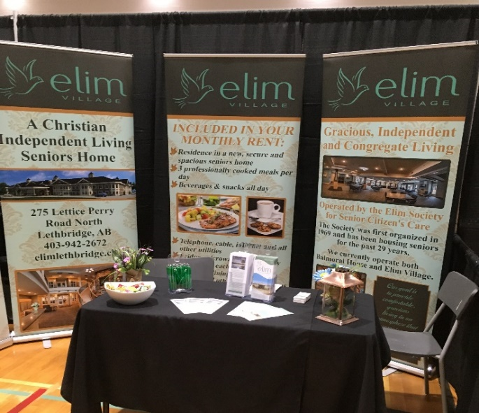
Live Well Showcase
One of the activities we participate in is the Live Well Showcase for Seniors at the Lethbridge Seniors Centre each year. You will find booths that feature everything a senior could be wondering about, including retirement living. We have experienced much interest in both of our buildings over the years when attending the showcase. This year it will be held June 4 & 5. Come by and visit our display.
Website
Be sure to look us up at elimlethbridge.ca You can find out everything about the Society and both our buildings, including the history, job opportunities and space availability.

Oldest resident 93 Youngest resident 60

NOTICE OF THE ANNUAL GENERAL MEETING (AGM)

Thursday, April 23, 2026 in the Grand Room, Elim Village
275 Lettice Perry Road North, Lethbridge @ 7:00 p.m.

Reviewed financial statements will be available on the Elim Society website two weeks prior to the AGM @www.elimlethbridge.ca Print copies may be picked up at the administration office at the Village during office hours and will also be available at the AGM.

Persons interested in serving on the Board of Directors are asked to contact the Board President prior to the meeting. Call or text or email Rene Barendregt at 403-394-5369, or barendregt@uleth.ca

Society memberships may be renewed or purchased at the AGM - $25.00 per person

AGENDA:

- WELCOME AND OPENING DEVOTIONS
- SINGING OF “Come Thou Fount of Every Blessing”
- ACCEPTANCE OF THE AGENDA
- MINUTES OF THE PREVIOUS AGM (Luke Hummel)
- BUSINESS ARISING FROM THE MINUTES
- PRESIDENT’S REPORT (Rene Barendregt)
- REPORT OF THE AUDITORS
  - Motion to accept report of 2025 financial review
- FINANCIAL REPORT (Harry Boessenkool)
  - Motion to accept reports
- NEW BUSINESS
- ELECTION OF NEW BOARD MEMBERS
  - Motion to accept Candidates
- QUESTIONS/MOTIONS FROM THE FLOOR
- CLOSING PRAYER (John Schalk)

Come Thou Fount of Every Blessing

- Come Thou Fount of every blessing,
Tune my heart to sing Thy grace;
Streams of mercy, never ceasing,
Call for songs of loudest praise.
Teach me some melodious sonnet,
Sung by flaming tongues above;
Praise the mount-I’m fixed upon it
Mount of Thy redeeming love.

- Here I raise my Ebenezer;
Hither by Thy help I’ve come;
And I hope by Thy good pleasure,
Safely to arrive at home.
Jesus sought me when a stranger,
Wandering from the fold of God;
He to rescue me from danger,
Interposed His precious blood.

- O to grace how great a debtor
Daily I’m constrained to be;
Let Thy goodness, like a fetter,
Bind my wandering heart to Thee.
Prone to wander, Lord, I feel it,
Prone to hate the God I love;
Here’s my heart, O take and seal it,
Seal it for Thy courts above.


275 Lettice Perry Road North
L Lethbridge, AB. T1H 7E7
Website: elimlethbridge.org

Dear Elim Society Members;
It’s that time of year again, time to renew your Society memberships! Please fill out the information below. Thank you; your financial gift enables us to achieve our mission and vision of providing quality living options to our Christian seniors and helps to secure the future financial viability of the Elim Society.

Last Name: First Name(s):

Address:

City: Postal Code:

Phone #: Email:

Church Affiliation:
This information is requested to support the efficient distribution of Society communications

Payment Options for Society Membership and/or Donations
- Cash
- By cheque payable to Elim Society for Seniors Care
- By e-transfer to bookkeeperelimsociety@gmail.com

Please mark your choice of membership payment and/or donation:
Membership ___ $25.00
Donation ___ $1000.00 ___$500.00 ___$200.00 ___ $100.00
___ Other - $ __________
Thank you for your payment and/or donation

Charitable tax receipts will be provided for membership and donations.
Registered Charity Number: 118897347RR0001, Alberta Charity #50005595
All donations raised during this membership renewal campaign will go to the Elim Society.

Contact Colleen at 403-942-2672 or 403-715-1929 for more information.

